An Inquiry of Pascal: The Wager
  - Group 1: Who/what is God?
    - What are the attributes of God according to Natural Reason?(Science)

__________________________________________________________________________________________________________________________________________________________________________________________________________________________________________________________________________________________________________________________________________________________________________________________________________________________________________________________________________________________________________________________________________________________________________________________________________________________________________________________________________________________________________________________________________________________________________________________________________________________________________________________________________________________________________________
__________________________________________________________________________________________________________________________________________________________________________________________________________________________________________________________________________________________________________________________________________________________________________________________________________________________________________________________________________________________________________

Paschal:
          - If one does not believe, and God exists, one has lost everything.
          - If one does not believe, and God does not exist, one has lost nothing.
          - If one does believe, and God does not exist, then nothing lost, nothing gained.
          - If one believes, and God does indeed exist, then one has gained everything.

Pascal’s Wager | God exists | God doesn’t exist
Wager for God | Gain all | Status Quo
Wager against God | Misery | Status Quo
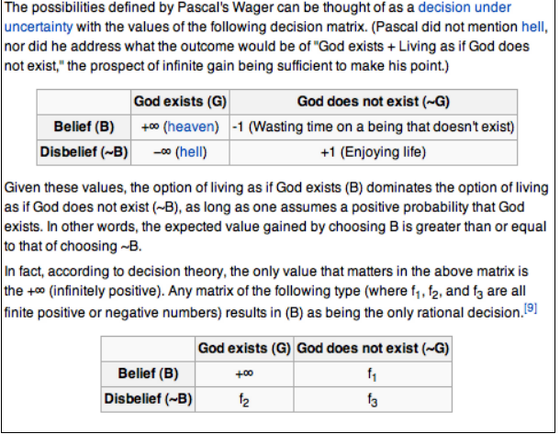

Does God Exist?_____________________________________________________________________________________
An Inquiry of Pascal: The Wager
  - Group 1: Who/what is God?
    - What are the attributes of God based on Faith?

__________________________________________________________________________________________________________________________________________________________________________________________________________________________________________________________________________________________________________________________________________________________________________________________________________________________________________________________________________________________________________________________________________________________________________________________________________________________________________________________________________________________________________________________________________________________________________________________________________________________________________________________________________________________________________________
__________________________________________________________________________________________________________________________________________________________________________________________________________________________________________________________________________________________________________________________________________________________________________________________________________________________________________________________________________________________________________

Paschal:
          - If one does not believe, and God exists, one has lost everything.
          - If one does not believe, and God does not exist, one has lost nothing.
          - If one does believe, and God does not exist, then nothing lost, nothing gained.
          - If one believes, and God does indeed exist, then one has gained everything.

Pascal’s Wager | God exists | God doesn’t exist
Wager for God | Gain all | Status Quo
Wager against God | Misery | Status Quo

Does God Exist?_____________________________________________________________________________________

